PLAN ROADMAP OF LANGGRAPH PROJECTS
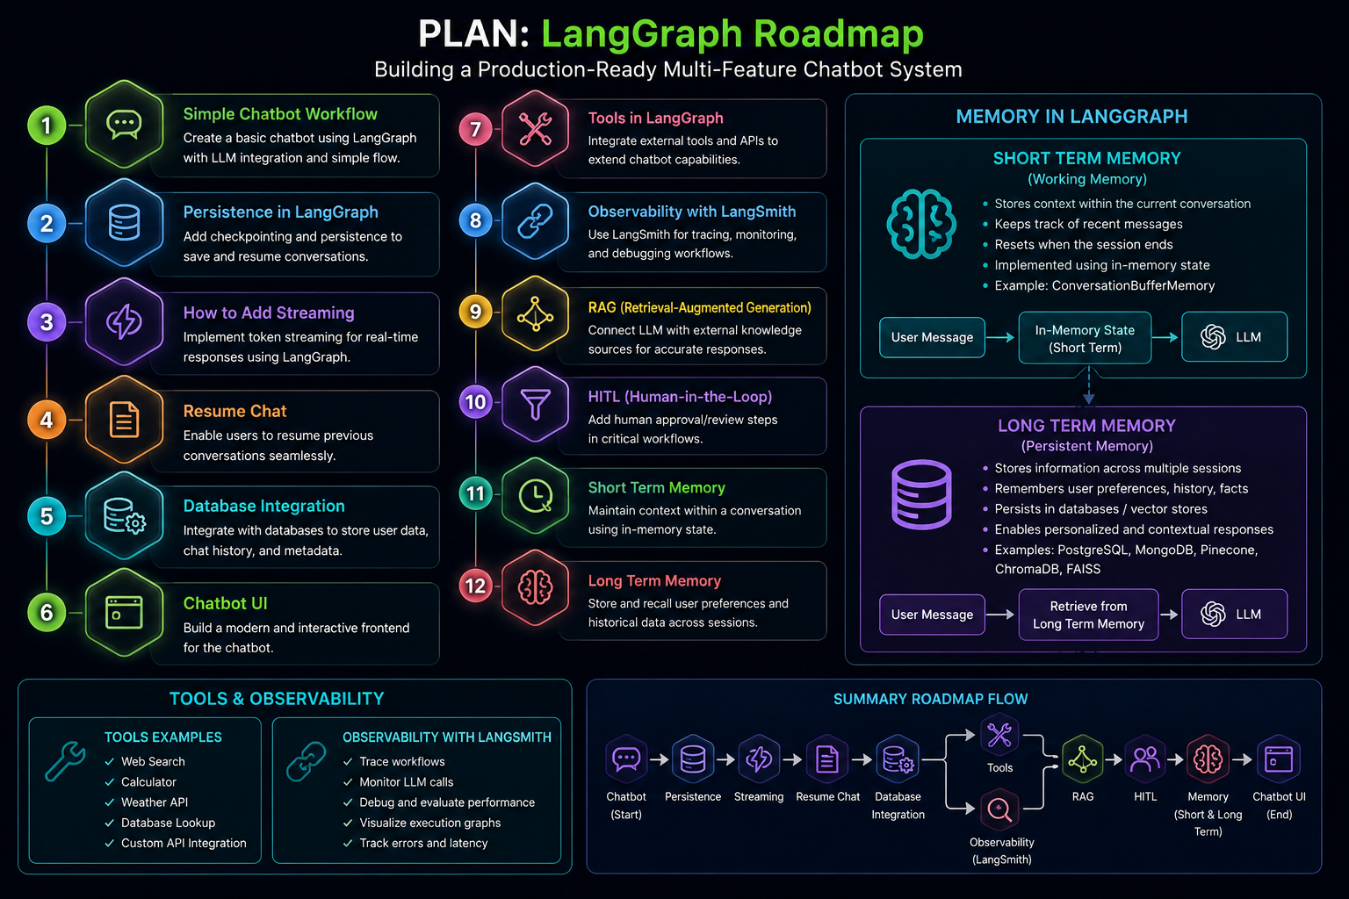

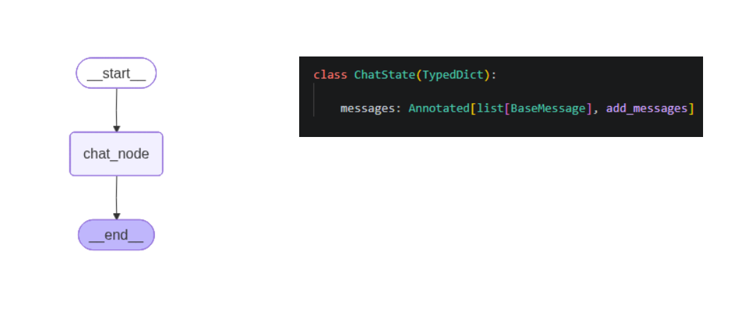

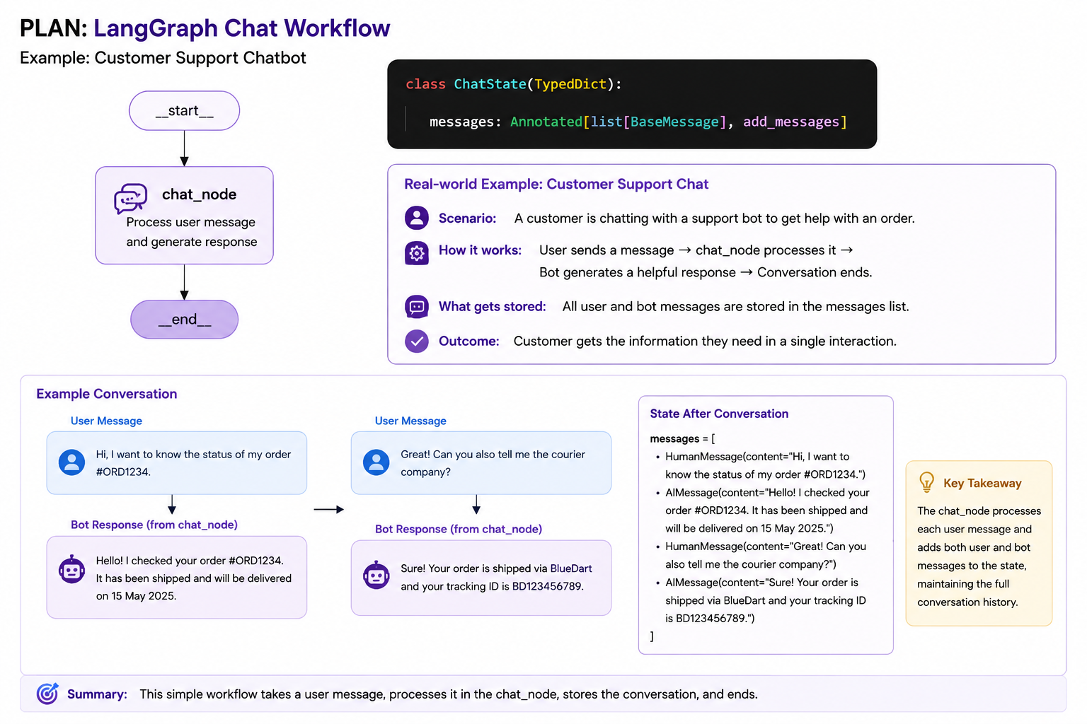
add_messages is a langraph function , we have to import from langgraph basically this add_message handles this kind of scenario it will take all of the conversation story like user message as well as the replied message and it will stored in the particular state and this state will go to the chat_node

1. The State
from typing import Annotated
from langgraph.graph.message import add_messages
from langchain_core.messages import BaseMessage

class ChatState(TypedDict):
messages: Annotated[list[BaseMessage], add_messages]
What is a State?
Think of the State as the memory box of your workflow.
Every node in LangGraph receives the current state, processes it, updates it, and passes it to the next node.
Current State
│
▼
+----------------+
| messages |
+----------------+
Instead of storing variables separately, LangGraph stores everything inside one dictionary-like object called the State.

2. What is messages?
messages
This variable stores the entire conversation.
For example:
User:
Hello

AI:
Hi! How can I help?

User:
Explain LangGraph.
All of these are stored inside
messages
as a list.

3. Why is it a List?
Because a conversation contains many messages.
messages

[
User Message,
AI Message,
User Message,
AI Message,
User Message
]
Every time someone speaks,
a new message is added.

4. What is BaseMessage?
list[BaseMessage]
LangChain stores every message as an object.
Example
HumanMessage(
content="Hello"
)

AIMessage(
content="Hi!"
)

SystemMessage(
content="You are a helpful assistant."
)
All these inherit from
BaseMessage
So
list[BaseMessage]
means
"This list can contain Human messages, AI messages, System messages, Tool messages, etc."

5. What is Annotated?
Annotated[list[BaseMessage], add_messages]
Normally Python would only know
messages is a list.
But LangGraph also wants to know
How should this list be updated?
That extra instruction is provided by
Annotated

6. What is add_messages?
This is the most important part.
Normally,
if a node returns
messages = [New Message]
the old messages would be replaced.
Example
Before
[
Hello,
Hi
]
Node returns
[
Explain AI
]
Without add_messages
Result
[
Explain AI
]
Everything else is lost.

With
add_messages
LangGraph automatically appends the new messages.
Before
[
Hello,
Hi
]
Node returns
[
Explain AI
]
Final state becomes
[
Hello,
Hi,
Explain AI
]
Nothing is lost.
It behaves like
list.extend()
instead of
=

7. Why do we need add_messages?
Imagine ChatGPT.
You ask
Hi
AI replies
Hello!
Then you ask
Who won the World Cup?
If previous messages were overwritten, the chatbot would forget the earlier conversation after every turn.
add_messages keeps adding new conversation turns so the chatbot remembers the chat history.

8. Workflow Diagram
START
│
▼
+--------------+
| chat_node |
+--------------+
│
▼
END
Step 1
The user sends
Hello
Current state
messages

[
Human:
Hello
]
↓
Step 2
The state goes into
chat_node
The node calls the LLM.
AI:
Hello! How can I help you?
↓
Step 3
The node returns
AI Message
Because of
add_messages
LangGraph automatically appends it.
New state
messages

[
Human:
Hello,

AI:
Hello! How can I help?
]
↓
Step 4
Workflow ends.

9. Real-Life Example
Imagine you're chatting with a customer support agent.
Conversation:
👤 User:
My internet isn't working.
🤖 AI:
I'm sorry to hear that. Can you restart your router?
👤 User:
I already tried that.
🤖 AI:
Let me run a network diagnosis.
The state becomes:
messages

[
User:
My internet isn't working.

AI:
Can you restart your router?

User:
I already tried that.

AI:
Running network diagnosis...
]
Because of add_messages, every message is preserved in order.

10. Flow Summary
User sends message
│
▼
Stored in messages
│
▼
chat_node reads messages
│
▼
LLM generates reply
│
▼
add_messages appends reply
│
▼
Updated conversation state
One-line summary
ChatState stores the conversation history, and add_messages ensures that every new user or AI message is appended to the existing history instead of replacing it. This allows LangGraph chatbots to maintain context across the conversation.

